1
Ex. No: 11 | ADD iOS AS A BUILD TARGET
Date of Exercise
Git-hub Host Link

Aim:

To configure a Flutter application for the iOS platform and understand the process of building and testing the application using Xcode and an iOS Simulator.

Description:

Flutter supports cross-platform application development, including iOS. The iOS build target allows developers to configure, build, and test Flutter applications on iOS devices. The iOS platform files are generated using the flutter create command. The application can be opened in Xcode, tested using an iOS Simulator, and built for iOS distribution. Actual iOS building and testing require macOS and Xcode.

Procedure:

Step 1: Check Flutter Installation

Execute the following command to check the Flutter installation and development environment.

flutter doctor

Step 2: Check Available Devices
List the connected devices using:

flutter devices

Step 3: Create a Flutter Project
Create a new Flutter application named ios_app. flutter create ios_app
cd ios_app

Step 4: Verify iOS Platform Files Check the generated iOS project files. dir ios
The project contains the Runner, Runner.xcodeproj, and Runner.xcworkspace directories.

Step 5: Analyze the Application
Check the application code for errors using:

flutter analyze

The analysis completed successfully with the message No issues found!.

Step 6: Open the iOS Project in Xcode

On a macOS system, open the iOS workspace using:

open ios/Runner.xcworkspace

Step 7: Select an iOS Simulator
Open Xcode, select an available iOS Simulator, and configure the application for execution.

Step 8: Run the Application
Execute the application using:

flutter run

Alternatively, run the application directly from Xcode.

Step 9: Test the Application
Verify the following application features:

- User interface
- Navigation
- Text fields
- Buttons
- Images
- Screen transitions

Step 10: Build the iOS Application
Build the application for iOS using Flutter on a supported macOS environment.

flutter build ios

Program:
import 'package:flutter/material.dart';

void main() { runApp(const MyApp());
}
class MyApp extends StatelessWidget { const MyApp({super.key});

@override
Widget build(BuildContext context) { return MaterialApp( debugShowCheckedModeBanner: false, title: 'iOS App',
theme: ThemeData( primarySwatch: Colors.blue,
),
home: const HomePage(),
);
}
}

class HomePage extends StatelessWidget { const HomePage({super.key});

@override
Widget build(BuildContext context) { return Scaffold(
appBar: AppBar(
title: const Text('iOS Build Target'),
),
body: Center( child: Column(
mainAxisAlignment: MainAxisAlignment.center, children: [
const Icon( Icons.phone_iphone, size: 80,
color: Colors.blue,
),
const SizedBox(height: 20), const Text(
'Welcome to Flutter iOS App', style: TextStyle(

fontSize: 22,
fontWeight: FontWeight.bold,
),
),
const SizedBox(height: 20), ElevatedButton(
onPressed: () { ScaffoldMessenger.of(context).showSnackBar( const SnackBar(
content: Text('Application is working!'),
),
);
},
child: const Text('Test Application'),
),
],
),
),
);
}
}

Output:
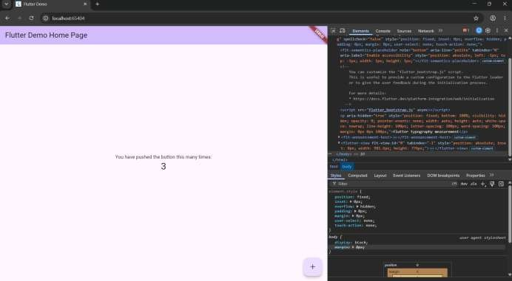

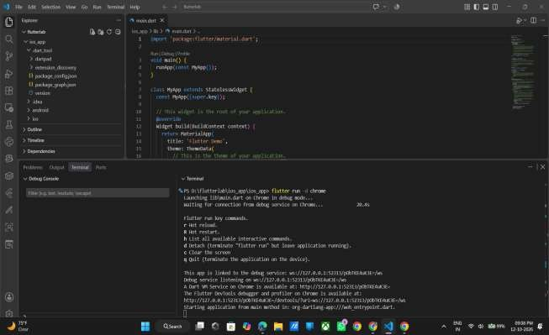

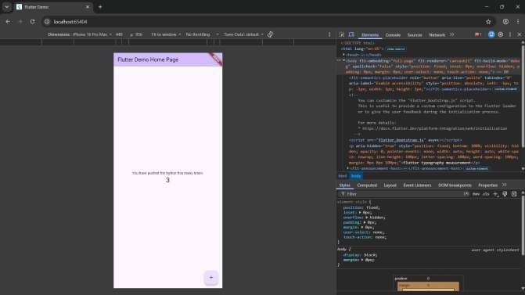

RESULT

The Flutter project was created successfully, and the iOS platform configuration files were generated. Static code analysis was completed successfully without any issues. Actual iOS building and simulator testing require macOS and Xcode.

